NAME: DANVER JOHN OMLANG

COURSE AND SECTION: SBIT-3K

**I. Github and Git**

a. What is the name of your Github account(public):

*The instructor can search your* ***github account****(github to github)*

b. Push your **sample programs** using command prompt from laptop or PC into Github.

* Don’t forget to perform git commit -m Version 1 by <COMPLETE NAME> like the figure 1.1-Github sample output below before you push into Github from your PC or laptop.

c. Attached your Github Screenshot output here:

Example:

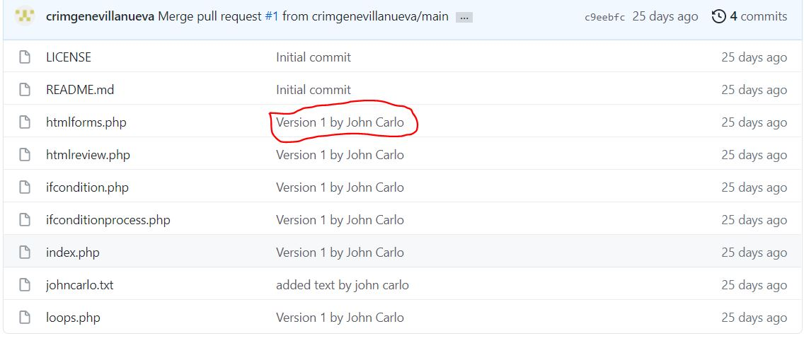

Figure 1.1-Github Sample Output

GitHub Screenshot:

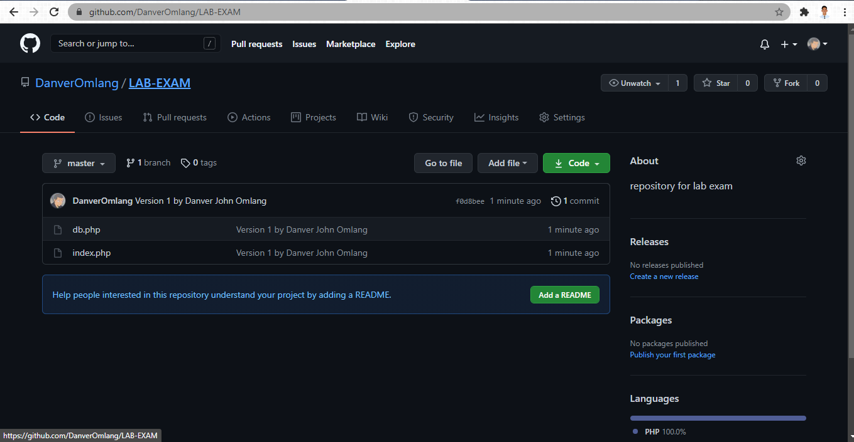

Github account

DanverOmlang [(danver.omlang@digitizr.net.au)](mailto:(danver.omlang@digitizr.net.au))

Repo Name : LAB-EXAM

**II. Clickup-Agile Procedure Set**

Invite me on your Clickup accout: [crimgene.villanueva@qcu.edu.ph](mailto:crimgene.villanueva@qcu.edu.ph)

1. Make Kanban board using Clickup, setting up your columns (TO DO, IN PROGRESS, DONE, CLOSED) 4 COLUMNS. Follow the figure 2.1 below.
2. Create new task-Midterm Lab<LASTNAME>. See figure 2.1 below.
3. Attached your Clickup Screenshot output here:

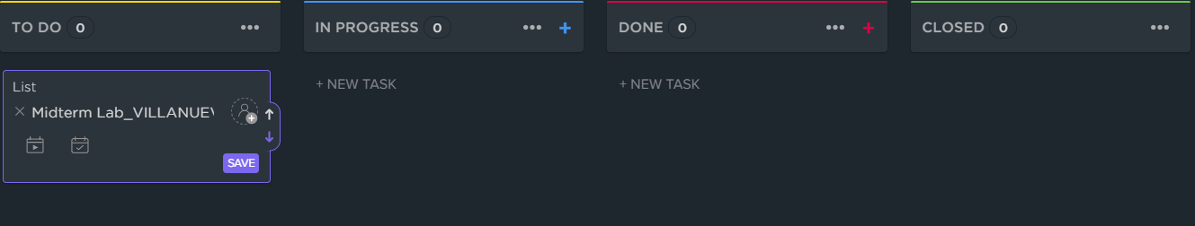

Figure 2.1-Clickup-Agile Procedure Set

CLICKUP SCREENSHOT:

